Concept Mapping

Michael Zeilik
Department of Physics & Astronomy
University of New Mexico

Why use concept maps?
Concept maps assess how well students see the “big picture”. They have been used for over 25 years to provide a useful and visually appealing way of illustrating students' conceptual knowledge.

What is a concept map?
A concept map is a diagram of nodes, each containing concept labels, which are linked together with directional lines, also labeled. The concept nodes are arranged in hierarchical levels that move from general to specific concepts.

WHAT IS INVOLVED?
Instructor Preparation Time: Minimal if students construct maps; large for designing "fill-in" maps.
Preparing Your Students: Students need training (about an hour) and continual practice.
Class Time: At least 30 minutes.
Disciplines: Appropriate for all.
Class Size: Small classes if students construct maps individually; cooperative teams constructing maps will work with large (or small) classes.
Special Classroom/Technical Requirements: None.
Individual or Group Involvement: Either.
Analyzing Results: Intensive for formal scoring for large classes; concept maps are generally not graded.
Other Things to Consider: Very demanding cognitive task for students.

Contents
- Description
- Assessment Purposes
- Limitations
- Teaching Goals
- Suggestions for Use
- Step-by-Step Instructions
- Variations
- Analysis
- Pros and Cons
- Theory and Research
- Links
- Sources
- Mike Zeilik

Description
A concept map is a two-dimensional, hierarchical node-link diagram that depicts the structure of knowledge within a scientific discipline as viewed by a student, an instructor or an expert in a field or sub-field. The map is composed of concept labels, each enclosed in a box or oval; a series of labeled linking lines, and an inclusive, general-to-specific organization. By reading the map from top to bottom, an instructor can:

- gain insight into the way students view a scientific topic;
- examine the valid understandings and misconceptions students hold; and
- assess the structural complexity of the relationships students depict.

In addition to these applications in assessment, faculty have also used concept maps to organize their ideas in preparation for instruction, as a graphic organizer during class, and as a way to encourage students to reflect on their own knowledge and to work together and share their understandings in collaborative group settings.

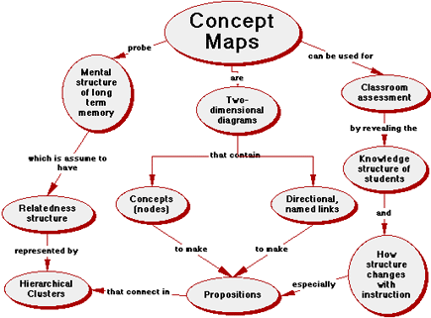

Figure 1: Concept Map Of Concept Maps

Assessment Purposes
To investigate how well students understand the correct connections among concepts in a subject, to document the nature and frequency of students' misconceptions, and to capture the development of students' ideas over time.

Limitations
Concept maps provide a useful and visually appealing way of depicting the structure of conceptual knowledge that people have stored in long-term memory. As a result, they offer a readily accessible way of assessing how well students see “the big picture.” They are not designed to tap into the kind of process knowledge that students also need to solve novel problems or for the routine application of algorithmic solutions. Because they probe an individual's or a group's cognitive organization, they are very idiosyncratic and difficult to compare, either among individuals or groups, or across time for the same individuals or groups.

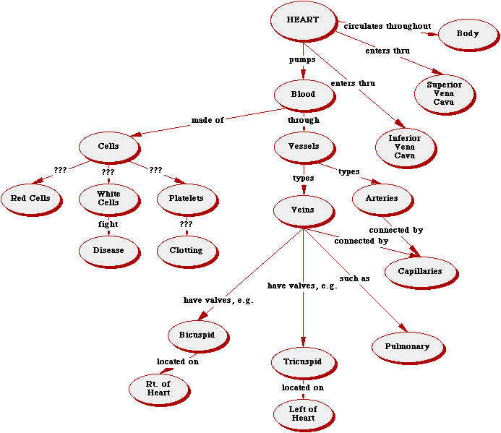

Figure 2: Jason’s Concept Map on the Human Circulatory System
[From Mintzes, Wandersee & Novak, 1998]

Teaching Goals
- Learn terms, facts, and concepts of this subject
- Organizes information into meaningful categories
- Synthesize and integrate information , ideas, and concepts
- Think about the “big picture” and see connections among concepts
- Think creatively about this subject
- Improve long-term memory skills for accessible knowledge
- Develop higher-level thinking skills, strategies, and habit
- Use graphics effectively

Suggestions for Use
Development of Course Design.
Global concept maps developed by an experienced instructor, or a team of instructors, can clarify the essential concepts and their linkages. They also make explicit the connected knowledge of a field, which is implicit among experts in the discipline. Effective instruction can then be designed that contains the structure of the concept maps. Caveat: This use requires a high investment of instructor time for the initial concept map construction.

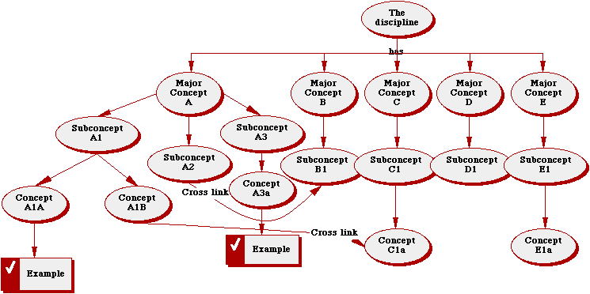

Figure 3: Schema for Using a Concept Map for Developing Course Design
[From Novak and Gowin, 1984]

Instructional Tool.
The instructor can present &quot;expert&quot; concept maps to the whole class to highlight key concepts and connections. These should be more detailed and flow from the global maps executed for the course design. Concept maps can then serve as &quot;advanced organizers&quot; (to preview material) and also for review. An instructor can continuously refer to a concept map in class to show how to &quot;grow&quot; the connections, and to keep the instruction focused. Caveat: At first, students will find concept maps very strange and may even try to memorize them, rather than use them as a thinking tool.

Learning Tool.
Ask students to construct their own concept maps covering a section of the course material from class or the textbook. Most (if not all!) of them will probably never have seen a concept map before, and many have not developed the learning skills needed to construct them. As a result, the instructor will need time (either in class, or perhaps in the lab) to work with groups and individuals. The impact of student-created concept maps is so powerful that it is worth the investment of time!

Step-by-Step Instructions
- Introduce a concept that is familiar to all students, such as “car”, “chair” or “food.”
- Have students write down 10 other concepts that they associate with this main concept (i.e., for food, “vegetables”, “meat”, “cereal”, “milk”, “steak”, “carrots”...).
- Ask them to rank the 10 concepts from “most general and inclusive” to “least general and inclusive” or from “most important” to “least important”; this step will require several minutes.
- Tell students to write the “most general” or “most important” concept near the top of a large piece of paper (e.g., posterboard or butcher paper are excellent, but regular notebook paper will suffice). Have them enclose this “superordinate concept” in a box or oval. Use pencils instead of pens! (Post-its™ are excellent for this step.)
- Explain that you want them to connect concepts from their list, one pair at a time, with directional links; and most importantly, to label the linking lines (e.g., Carrots → vitamin A (linking word is, “contain”) OR meat → iron (linking words are, “is a good source of”). Continue this process until all concepts appear on the map.
- Give students plenty of time (20-30 minutes). Encourage them to include a lot of branching and many levels of hierarchy. Put special emphasis on cross-linking concepts in one area of the map with those in other areas. Suggest that they may add as many additional concepts as they wish to make their maps unique and personally meaningful. Remind them that the boxes or ovals should contain only one or two words. Emphasize that “neatness doesn't count” and that they may re-draw their maps as often as they wish.
- Circulate around the room as students construct their maps. Be supportive but not directive. Remind students that a concept map is an distinctive representation of their understanding, and that individual components on their maps may or may not be scientifically accurate, but there is a large set of ways to organize and represent what they know. Encourage creativity and stress that there are no one “correct” answer.
- Select several students to share their maps with the class. You may need to make a transparency to display the maps in large classes. Focus attention on appropriate connections between concepts. Remind students that concept maps may be a very helpful way to study; they can be used to condense many pages of textbook verbiage into a succinct summary of what the author presents.
- In the next class, introduce a central concept from your course (e.g., “star”, “cell”, “energy”, “matter”) and ask your students to construct a concept map on this topic. Collect the maps and review them, but don't grade them. You may want to suggest ways the maps could be improved.
- Return the maps to the students and suggest that they rethink some of their ideas. We have used different colored pencils for each iteration so students may depict and emphasize how their ideas change over time. The same map may be used for several class periods, and students may be encouraged to add to, delete, reorganize or even begin anew whenever they need to do so.

Variations
Collaborative Concept Mapping
Sometimes the frustration levels can be very high when concept mapping is first introduced, especially in large classes of relative novices. To counter some of this anxiety and to encourage students to reflect on their own thinking, groups of 3 or 4 students to work together on a concept map. This exercise is often a very rewarding and rich learning experience as peers argue, debate, and cajole each other. The result is a genuine effort to negotiate the meaning of scientific concepts, attempting (as scientists do) to reach consensus, or to stake out different points of view. The power of the process resides in the interpersonal sharing of ideas, which are made explicit to the instructor.

Fill-in Concept Mapping
You construct a concept map and then remove all of the concept labels (keep the links!). You then ask the class to replace the labels in a way that makes structural sense. Best done with small classes; a good way to introduce a new topic.

Select and Fill-in Concept Mapping
You create a concept map and then remove concepts from the nodes (about one-third of them). These deleted concepts are placed in a numbered list on the map and students choose among them. Scoring can be as simple as “percent correct.” Instructors of large classes may use multiple-choice type scanning sheets. The assumption of this technique is that as students' thinking approximates that of the instructor, the closer their connected knowledge is “expert-like.” The key is to select nodes that are at different levels of the hierarchy and have nearby or antecedent links.

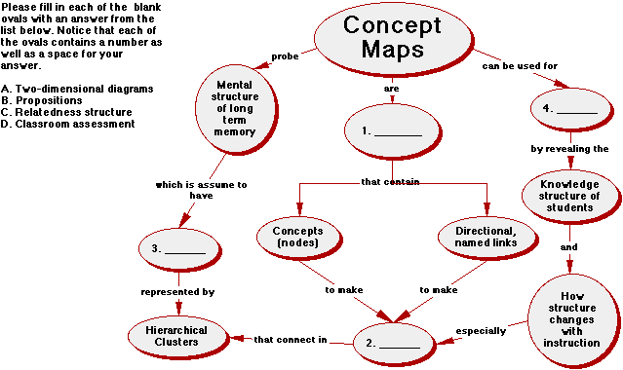

Figure 4: Select and Fill-in Concept Map on Concept Maps
[See Figure 1 for the “answers”]

Selected Terms Concept Mapping
You provide a list of concept labels (10 to 20) and ask students to construct their maps using only these labels. The focus here is on the linking relationships, and the evolution of structural complexity of students' knowledge frameworks.

Seeded Terms Concept Mapping
In this approach, also known as “micromapping” (Trowbridge and Wandersee, 1996), you furnish a small set of concept labels (5 to 10) and invite students to construct a concept map using these, and an equal number of labels drawn from their own knowledge of the topic.

Guided Choice Concept Mapping
Here you present a list of some 20 concept labels from which students select 10 to construct their maps. When done over a period of time, the instructor focuses on which concepts appear and which disappear. The assumption is that these changes represent significant restructuring of the students' knowledge frameworks.

Analysis
To start, we suggest that you focus primarily on the qualitative aspects of students' concept maps with emphasis on the accuracy or validity of the knowledge students represent. Among the questions you might ask yourself are the following:
- Are the most important concepts depicted?
- Are the links among concepts scientifically acceptable?
- Is there a substantial amount of branching hierarchy and cross-linking?
- Do any of the propositions suggest that the student subscribes to significant misconceptions?
- How have students’ concept maps changed over the course of days or weeks?

As you and your students gain experience with concept mapping, you might consider trying one or more of the quantitative “scoring rubrics” currently available (Novak and Gowin, 1984). In the most well-established scoring scheme, 1 point is given for each correct relationship (i.e., concept-concept linkage); 5 points for each valid level of hierarchy; 10 points for each valid and significant cross-link; and 1 point for each example.

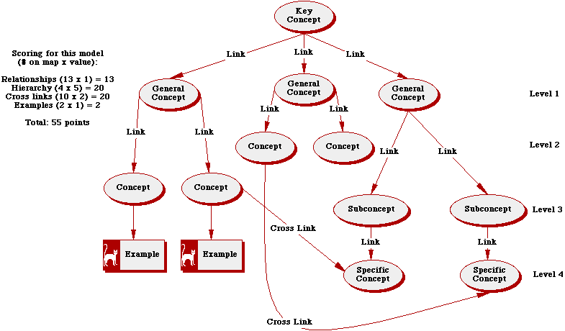

Figure 5: Scoring Concept Maps
[from Novak and Gowin, 1984]

Pros and Cons
- Concept maps help students focus on the “big picture”, enabling them to devote more of their time to conceptual understanding rather than rote learning
- Concept maps force students (and instructors!) to make valid connections among concepts
- They provide a low tech (cheap!) vehicle that enables students to represent graphically their knowledge, and to share it with the instructor and other students
- They shift the emphasis from inert, static knowledge to contextually-embedded knowledge; from isolated facts to theoretical frameworks of related concepts
- In addition to their role as assessment tools, concept maps offer a useful way to help students “learn how to learn”; they also serve as useful vehicles for course development and as graphic organizers before, during and after instruction

However:

- Comparisons among students are more difficult because concept maps tend to reveal the idiosyncratic way that students view a scientific explanation, as a result...
- Evaluation can become more time-consuming for the instructor, especially in large classes, unless some variation (such as Select & Fill-in) is adopted
- If you score maps, you must use a consistent (and tested) scheme
- Students who have developed a strong facility for rote learning of verbal knowledge sometimes find concept maps intimidating
- Constructing concept maps is a demanding cognitive task that requires training

Theory and Research
Concept mapping emerges directly from David P. Ausubel's Assimilation Theory of meaningful verbal learning (Ausubel, Novak, and Hanesian, 1978). The underlying basis of the theory is that meaningful (as opposed to rote) human learning occurs when new knowledge is consciously and purposively linked to an existing framework of prior knowledge in a non-arbitrary, substantive fashion. In rote (or memorized) learning, new concepts are added to the learner's framework in an arbitrary and verbatim way, producing a weak and unstable structure that quickly degenerates. The result of meaningful learning is a change in the way individuals experience the world; a conceptual change. Joseph D. Novak and his colleagues at Cornell University developed the concept mapping technique in the early 1970s. Concept maps have been used for over 25 years in research and classroom practice to reveal and assess the structure and complexity of knowledge held by students in the sciences and other disciplines (Novak and Gowin, 1984).

The core element of a concept map is a proposition, which consists of two or more concepts connected by a labeled link. In a concept map, propositions are connected to each other to form a hierarchical, branching, and dendritic structure that represents the organization of knowledge in long-term memory. The basic assumption of the concept map is that &quot;interrelatedness&quot; is an essential property of knowledge, and that &quot;understanding&quot; can be represented through a rich set of relations among important concepts in a discipline.

More than two hundred studies in science education have employed concept mapping in one form or another (Novak, 1998; Novak and Wandersee, 1990; Mintzes, Wandersee and Novak, 1998). Several of these investigations have examined the reliability and validity of the technique as a way of representing knowledge in scientific disciplines (Markham, Mintzes and Jones, 1994; Pearsall, Skipper, and Mintzes, 1997; Ruiz-Primo and Shavelson, 1994; Songer and Mintzes, 1994; Wallace and Mintzes, 1990). In general, these and other studies suggest that the technique has many of the desirable characteristics that testing and measurement experts look for in new assessment tools. For example, in one study (Markham, et al., 1994) it was shown that the conceptual frameworks revealed by concept maps reflect essentially the same structure as that seen in much more time-consuming techniques, such as interviews and picture sorting tasks. In another study (Pearsall, et al., 1997), successive concept mapping conducted over the course of a full semester in introductory college biology, revealed a cumulative, step-wise growth in knowledge that one would expect to see if the technique taps into students' expanding conceptual frameworks.

Several studies suggest that concept map scores do not correlate significantly with traditional measures of learning such as multiple choice tests. Novak, Gowin, and Johansen (1983) showed that mapping scores were not significantly related to students' SAT scores. These findings suggest that a concept map taps into a substantially different dimension of learning than conventional classroom assessment techniques. It is likely that many techniques commonly used in college science courses focus largely on rote aspects of learning. On the other hand, Schau and Mattern (1997) found that posttest scores on &quot;Select and Fill-in&quot; maps drawn by graduate students in introductory statistics correlated significantly with final course grades (correlation coefficient, r=0.85; N=15). Among novice astronomy students, Zeilik, et al. (1998) reported a substantially weaker relationship (r ≈ 0.4; N ≈ 700). The interpretation from this study is that traditional evaluation tools (quizzes, tests, final grades) capture some aspects of conceptual structure, and concept maps capture other aspects.

Links
- Joel J. Mintzes, Professor of Biological Sciences, University of North Carolina at Wilmington. Interests: cognition and learning in biology; concept mapping; conceptual development in the natural sciences. Web page: http://www.uncwil.edu/people/mintzes
- Joseph D. Novak, Professor Emeritus of Science Education and Biological Sciences, Cornell University. Interests: concept mapping, metacognition, vee diagrams. Email: Jdn2@cornell.edu
- James H. Wandersee, Professor of Biological Education, Louisiana State University. Interests: graphic organizers (e.g., concept maps); history & philosophy of science in science teaching. Web page: 15DegreeLab@worldnet.att.net or email: ciwand@lsuvm.sncc.lsu.edu
- Michael Zeilik, Professor of Astronomy, University of New Mexico. Interests: conceptual astronomy; concept mapping. Email: zeilik@chicoma.la.unm.edu
- National Association for Research in Science Teaching (NARST). Web page: Science.coe.uwf.edu/NARST/NARST.html
- The software package Inspiration aids in creating concept maps. It is easy to learn and use. http://www.inspiration.com

Sources
- Angelo, Thomas A. and Cross, K. Patricia (1993). Classroom assessment techniques: A handbook for college teachers. 2nd edition. San Francisco: Jossey-Bass Publishers.
- Austin, L.B. and Shore, B.M. (1995). Using concept mapping for assessment in physics. Physics Education 30 (1): 41-45.
- Markham, K., Mintzes, J. and Jones, G. (1994). The concept map as a research and evaluation tool: Further evidence of validity. Journal of Research in Science Teaching, 31(1): 91-101.
- Mintzes, J.J., Wandersee,J.H. & Novak, J.D. (1998). Teaching science for understanding: A human constructivist view. San Diego, CA: Academic Press.
- Novak, J.D. (1998). Learning, creating and using knowledge: Concept maps as facilitative tools in schools and corporations. Mahwah, NJ: Lawrence Erlbaum.
- Novak, J.D. & Gowin, D.B. (1984). Learning how to learn. Cambridge University Press.
- Novak, J.D. & Wandersee, J.D., (Eds.), (1990). Perspectives on concept mapping. Journal of Research in Science Teaching, 20 (10); Special Issue.
- Pearsall, R., Skipper, J., and Mintzes, J. Knowledge restructuring in the life sciences: A longitudinal study of conceptual change in biology. Science Education, 81, 193-215.
- Pendley, B.D., Bretz, R.L. & Novak, J.D. (1994). Concept maps as a tool to assess learning in chemistry. Journal of Chemical Education, 71 (1): 9-15.
- Ruiz-Primo, M. and Shavelson, R. (1996). Problems and issues in the use of concept maps in science assessment. Journal of Research in Science Teaching, 33 (6): 569-600.
- Schau, C. and Mattern, N. (1997). Use of map techniques in teaching statistics courses. The American Statistician, 51 (2): 171-175.
- Wallace, J. and Mintzes, J. (1990). The concept map as a research tool: Exploring conceptual change in biology. Journal of Research in Science Teaching, 27(10): 1033-1052.
- Zeilik, M., Schau, C. and Mattern, N. (1998). Conceptual astronomy II: Replicating conceptual gains, probing attitude changes across three semesters. Submitted to The American Journal of Physics.
- Zeilik, M, Schau, C., Mattern, N., Hall, S., Teague, K. & Bisard, W. (1997). Conceptual astronomy: A novel model for teaching postsecondary science courses. American Journal of Physics, 65 (10): 987-996.

Mike Zeilik
I took a faculty position at the University of New Mexico directly from graduate school at Harvard, where I had pioneered the use of the Personalized System of Instruction/Keller Plan in astronomy. I threw myself into the introductory astronomy course for novices at UNM and was shocked at the poor performance of the class as a whole. Lacking resources to implement PSI, I struggled to create a learning environment in a large class of mature students with diverse backgrounds. I kept improving the standard model and saw student evaluations of my teaching climb. But I was struck at the end of one semester on how little students grasped the big picture of astronomy and how common misconceptions resisted change. Searching for solutions, I hit upon concept maps, which became central to our course transformation, and a disciplinary-based research project on conceptual development of novice students. I now use concept maps in all facets of instruction and assessment, for all levels of courses. I am particularly fascinated that the process of concept mapping can reveal structure that I did not anticipate in my maps or in students' maps; it's a great aha! Moment!

